Instructions for Use of
Grove Farm

Use Philosophy
Grove Farm is available to the public and campus community for education and research activities including meetings, retreats, and alumni activities. Because of its remote location on land leased from the Army Corps of Engineers, several safety communication and clean-up policies differ from those of other campus facilities.

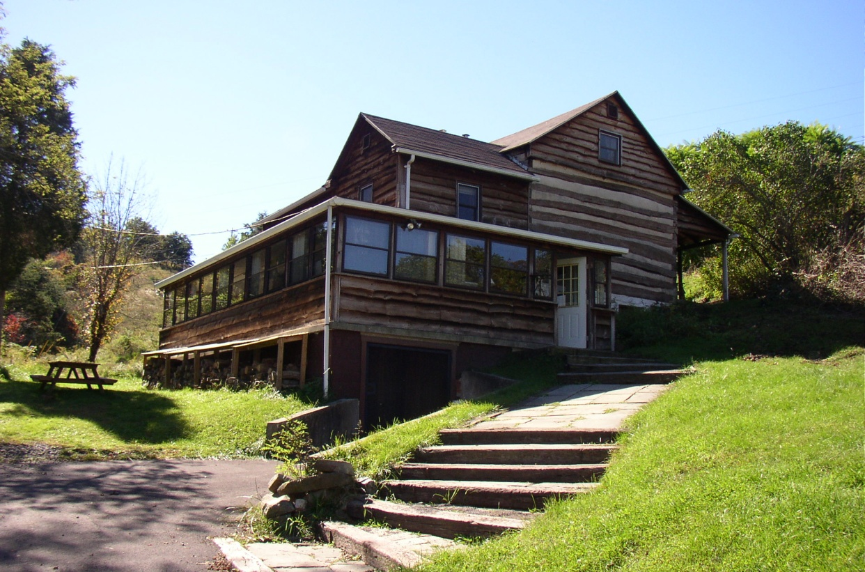

Index

Facilities
Usage fees 3
Key Return 3
Trash and Recycling 3
Accessing Other Facilities 3
Pet Policy 3
Phone Access 3
Computer Access 4
Facilities Description and to bring list 4

Travel
Gate Information 4
Speed Limits 5
Snow Removal 5
Directions to Nearest Gas Station 5

Safety Information
Emergency Response 5
Allergies 6
Power and Phone Outages 6
Fire Alarms/Fire Policy 6
Smoking 6
Food Storage 6
Wildlife 6
Machine Use 6
Alcohol 7
Hunting, Firearms, and Illegal Substances 7

Indoor Fireplace
Cleaning ashes, lighting fire, blower fan 7/8

RFS Harbor
Swimming 8
Fishing 8
Boating 8

Cleaning
Use of Cleaning Supplies 9

Checkout List
Check out list and reminders 10

Report Form
Report Form 11

Facilities

Usage Fees
Contact the RFS office about use fees. Checks for use fees are payable to Juniata College. Please send your check to

Field Station Office, BAC
1700 Moore Street
Huntingdon, Pa 16652

Key Return
If necessary; please make sure to return Grove Farm key promptly to Juniata College’s office of Conferences and Events in Ellis College Center.

Trash and Recyclables
Please sort your waste into recyclables (glass, tin and aluminum, #1 & 2 plastics, paper and cardboard), compost (vegetable matter, soiled paper including paper plates, no meat or dairy), and garbage (non-compostable or recyclable). Avoid use of non-reusable or non-recyclable materials including disposable silverware and plates (especially Styrofoam). Do not leave unused disposable plates and silverware behind at the station. Dump compostable materials (including soiled paper) in the outdoor compost bin. There is a small compost bucket in the kitchen.

Accessing Other Facilities
Please confine your activities to the area(s) that you have rented unless you have made arrangements with the RFS office. Other facilities may be in use by different groups. When out hiking, please be considerate of other groups.

Pet Policy
Pets must be kept on leash or at heal at all times. Pets are not allowed in the station buildings.

Phone access

There is a phone in Grove Farm, please plan to use a calling card for long distance calls. For cell phones, ATT and Verizon service is generally available. You can contact Grove Farm by calling 814-658-3060.

Computer access

There is no internet access at Grove Farm. Laptop computers may be available for educational purposes through the station office.

Facilities Description and To Bring List

Grove Farm is equipped with a complete kitchen with microwave, coffeemaker and stove, and is stocked with dishes and pots. There are 4 bedrooms, two with two beds each, one with 4 beds and one with 5 beds for a total capacity of 13 beds. Not all beds are supplied with bedding, so please plan to bring your own bedding and pillows (some are available if you forget).

To bring for overnight use:

Flashlights
Pillows and sheets/blankets or sleeping bags
Toiletries
Towel

Travel

Gate Information
The gate combination is 5653. While at the station you may leave the gate unlocked, but always leave the lock and bar mechanism secured so that it cannot be stolen. Also please close the gate against the locked bar so that it appears to be locked (see diagram below). Note- the combination lock will spring back open if you do not turn the dials after you have locked it. Unlocking tip: After turning the dials to 5653, push the lock together, and then it will pop apart. Just pulling it apart does not work.
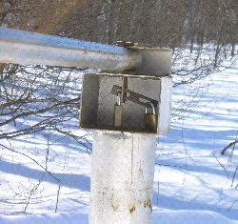  Vertical Bar through Gate | 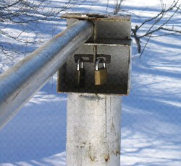  Vertical bar not through gate
Gate in locked configuration | Gate unlocked

Speed Limits
Obey posted speed limits. You are endangering yourselves, pedestrians and wildlife if you exceed these limits. Vehicles are only allowed on the paved surfaces and in designated parking spaces. Do not drive on gravel shoulders and un-paved trails or roads.

Snow Removal
During snow season, the station road is cleared after each snowfall but, unlike local roads, it is not kept clear during storm events. If you have an activity scheduled at the station during snow season, monitor the weather forecast and plan accordingly. We will only dig you out after a storm system has passed.

Directions to Nearest Gas Station
Follow the station to the gate, and turn left on James Creek Road. This will come to a T intersection with 994 – turn right on 994. There is a gas station on the left at the intersection of 994 and Rt 26.

Safety Information

Emergency Response
Emergency phone numbers are posted by the telephones. Use 911 for fire and ambulance emergencies. Estimated response time to the Station is 20 to 30 minutes. A first aid kit is located in the closet in the dining room. The nearest hospital is in Huntingdon.
Emergency or Issue | Who to Contact | Contact Information
Fire & Ambulance | 911 and Campus Police | 911 and 641-3636
Major crime response | State Police and Campus Police | 627-3161 and 641-3636
Reportable theft | Campus Police | 641-3636
Reportable auto accident | Campus Police | 641-3636
Boat accident | Fish & Boat / Campus Police | 641-3636
Minor injury | Field Station Office | 641-3572
Spill response | PA DEP / Ranger | 946 7290 / 658-3405
Lake visitor conflict | Ranger | 658-3405
Wildlife issue | Game Commission | 643-1831
Other | RFS Directors  Chuck and Sharon Yohn | 641-3572 (w)  Chuck cell: 814-599-9479 or Sharon cell 599-9484

Allergies
There are numerous stinging insects and occasional venomous snakes at RFS. Be careful. If you have allergic reactions you must keep appropriate medication with you and inform others of your allergies.

Power and Phone Outages
Service outages often occur in rural wooded areas. For emergency contact purposes, you may borrow a cell phone from the office of Conferences and Events. The phone is not to be used for personal calls. ATT and Verizon service is reliable at the station. Signal from other service providers is usually not available.

Fire Alarms and Fire Policy
- The fire alarm is not connected to a fire department or to campus.
- If the fire alarm goes off, it can be disabled by pressing 1 (off)
- Do not disable or tamper with the smoke detectors or fire extinguishers.
- No candles or other open flames are permitted in Grove Farm.
- Outdoor fires are allowed only in designated fire rings. Do not burn trash in the fire pit.
- You may use the indoor fireplace. Please read the directions in the indoor fireplace section before use. These directions are also posted by the fireplace.
Smoking
All RFS facilities are no smoking areas. Smoke outside only and away from buildings. Do not discard cigarette butts on the ground.

Food Storage
Please keep food in refrigerator or cabinets. Do not store food on the counters over night, mice will eat it. Do not leave your leftovers behind.

Wildlife
Do not disturb any wildlife. Any captured animal should be promptly returned to where you found it. No collecting of specimens without valid permits and prior permission of the Station Director is prohibited. Rabies does occur in the area so keep well clear of animals that that display unusually aggressive or friendly behavior. Keep in mind that rabies can be transmitted through carcasses.

Machine Use
Do not use boats, the tractor or any other power tools unless you have prior permission from the Director and proper training. Boat operators must have a boater safety license and RFS training.

Alcohol
Because of the remoteness of the site and related safety issues, alcohol consumption is prohibited at RFS. Exceptions to this policy may be granted for registered functions by the Field Station Director, Assistant Director of Campus Activities or the Office of Conferences and Events.

Hunting, Firearms and Illegal Substances
Firearms and illegal drugs are prohibited at RFS. Hunting is not allowed on the station property, but hikers should wear orange when in the woods, especially during the fall.

Indoor Fire Place

Read all Directions Before Starting a Fire
1. Check the level of the ashes. If the ashes are close to spilling out the door, you
must remove the ashes before lighting your fire. See below for directions.
2. Burn dry wood only.
3. Do keep all combustible materials (furniture, shoes, etc.) at least 4 feet away from
the front of the fireplace.
4. Never use gasoline, type lantern fuel, kerosene, charcoal lighter fluid or the like to
start or freshen up a fire in this fireplace. Keep all such liquids well away from the
fireplace.

Cleaning of Ashes
- If ashes are spilling out when you open the door, you must remove the ashes prior to building and lighting your fire.
- Next to the fireplace are tools and an ash bucket.
- Open the doors, and with the poker, remove the ash pan plug from its hole. It is located in the middle of fireplace bed.
- Make sure the ash pan is in the proper position to catch the ashes from the hole.
- Then push the ashes through the hole.
- When the ash pan is full, open the bottom louvers & remove the ash pan.
- Using the shovel from the tools, scoop out the ashes and place in the bucket.
- Replace the ash pan & louvers.
- Replace the plug; ensure it is properly placed before lighting your fire.
- Do not remove ashes from the fireplace bed while they are still hot.
- Warning - Do not discard hot ashes – they are a fire hazard.

Lighting of Fire
1. Pull the draft control (above the doors) all the way out.
2. Light a fire in the fireplace, starting with paper and kindling only.
3. Then add 2-3” diameter pieces of wood.
4. After fire is established, close the doors to prevent overheating.
5. Once a coal bed is established, add standard cord wood.
6. Leave the draft control open until the fire is well lit.
7. Adjust the draft control to the level you desire.
Blower Fan
On the left side of the fireplace is a blower fan rheostat to circulate warm air from the fire. Once the fire box heats up, the rheostat is activated. Turn the rheostat clockwise to increase the blower speed. When set to automatic, the rheostat will automatically shut off when the fire has cooled.

RFS Harbor

Swimming
Swimming is allowed around the immediate dock area. No lifeguard is provided – swim at your own risk. Stay around the dock area; do not swim out into the harbor. No diving! (The lake is full of slightly submerged logs and the dock area is shallow). Wear shoes when wading and while on the dock. Beware of sharp stones and splinters.

Fishing
Fishing is allowed around the immediate dock area only. You must have a valid fishing license. Do not fish from shore or from boat in the main harbor.

Boating
No recreational boating is allowed in RFS harbor. This includes college employees, students, and RFS guests. If you bring a boat to RFS, you must register it with the station office one week prior to arrival. Otherwise you will be fined by the waterways patrol. Recreation, including canoeing, water sports and fishing are not allowed in the harbor, even if you are in an RFS boat. Move to another inlet for recreational activities. Boats may pass through the harbor to access the dock, if registered with station office.

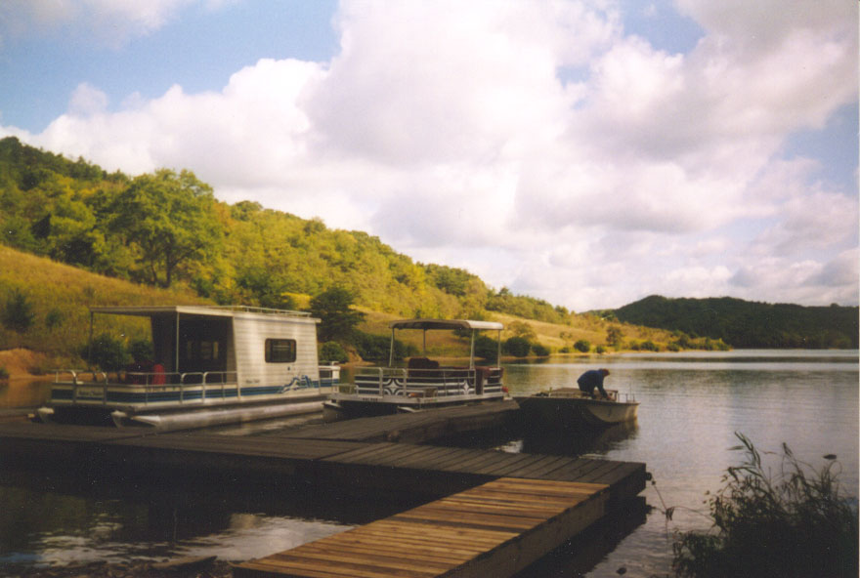
Use of Cleaning Supplies
- In addition to standard cleaning supplies, RFS stocks some commercial cleaning supplies. Please be sure to follow the instructions below if you choose to use these products.
- Use the appropriate cleaner at the correct dilution for the job.
- Pay attention to safety procedures.
- Protect the treatment plant from strong disinfectants.
For windows, other glass surfaces, basins, showers and toilets
use Fast & Easy spray bottle or Full sparkle (diluted 20 to 1)
Safety note – use latex gloves when handling concentrated liquid
Do not use on wood furniture or polished surfaces
____________________________________________________________________
For light cleaning / disinfecting counter tops, appliances and other hard surfaces
use FULLSAN from spray Bottles (diluted 40 to 1)
Safety note – use latex gloves when handling concentrated liquid
____________________________________________________________________
For heavy cleaning grease on counter tops, appliances and other hard surfaces
use Tough Duty spray bottles
Safety note – use latex gloves
Spot check before use on painted surfaces
____________________________________________________________________
For mopping tile floors
use Damp Mop (diluted 40 to 1) or 3 oz per gallon

Report cleaner restocking needs to the RFS office

Checkout List

Kitchen
- Clean out refrigerator / do not leave food behind.
- Wash, dry and put away all dishes and kitchen utensils
- Clean kitchen sink
- Wipe down interior and exterior surfaces of refrigerator / clean up spills
- Put dirty dish towels in laundry hamper
- Empty small compost bin into outdoor compost pile / rinse residue
- Check coffee maker basket – clean as needed
- Clean out interior of microwave oven
- Clean off counter tops, stove top and sides, burner trays and in and around oven
- Wipe up any spills from the floor
Porch
- Wipe down tables as needed
- Wipe up any spills from the floor
- Sweep floor as needed
- Vacuum entry rugs as needed
Around Building
- Sweep stairs
- Return furniture to original configuration
- Return any supplies or equipment to their original location
- Clean dry erase boards
- Make certain that the facility is locked up upon your departure
- Clean, and return gas grill to shop if used.
- Restock fire wood and kindling
- Dump ashes from fireplace
Bedrooms
- Return furniture to original configuration
- Put any RFS soiled linens into the hamper (located by the refrigerator)
- Check that all personal items are removed
- Vacuum rugs as needed
Bathrooms
- Put any RFS soiled linens into the hamper (located by the refrigerator)
- Check that all personal items are removed
- Vacuum rugs as needed
Other
- Lock all doors before leaving
- Fill out station log (located on the station desk) or fill out the report form on the next page.
- Leave windows open during summer (until the end of September) and closed during the winter (end of April).

Promptly report any damage or maintenance issues to the
Field Station Office (641-3572)

Report Form

Please promptly report any maintenance or supply needs to the station office – 641-3572.

Name:

Reason for usage:

Contact Phone Number or E-mail:

Number of people in group:

Length of stay:

Number of volunteer hours worked if any:
(For JC alums, parents and students, please list names and total hours)

Comments, observations and suggestions:

